

**A**

**Project Report On**

**“Medical Store Management”**

**Submitted By**

Vikash Singh (4347)

Deepak Kumar Singh (4359)

Saurav Kumar (4339)

Himmat Singh(4552)

Under the guidance of

**Prof. Yuvraj N Gholap**

For the fulfillment of

T.E (INFORMATION TECHNOLOGY)

2015-16

**Certificate**

This is to certify that Mr. Vikash Singh has successfully submitted the project report on

“**Medical Store Management”**

during the academic year 2015-16 in the partial fulfillment of requirement for the Mini Project of Database Management System Vth Semester, of the Army Institute of Technology, Pune.

**Dr. (Mrs.) Sangeeta Jadhav** **Prof. Y N Gholap**

*Head of Department Guide*

*Information Technology Information Technology*

*Principal*

**ACKNOWLEDGEMENT**

I take this opportunity to express my sincere gratitude to **Prof. Y N Gholap** for his immense support and guidance. Without the help and vision provided by him , this project report would not have achieved its present form. I am indebted to **Prof. (Dr.) Sangeeta Jadhav** (Head of Department, Information Technology) for providing me with all the facilities required for the seminar work.

I would like to thank other staff members of the information technology department who have helped me at various stages in the preparation of this seminar, for which I am thankful to them. Last but not the least I would like to extend my thanks to all my friends for their help, which led to the completion of the report.

Himmat Singh

Roll No : 4352

**INDEX**

**Sr. No Content Page no.**

1. Introduction 4
2. Feasibility Study 5
3. Proposed System 6
4. Design 8
5. Snapshots 9
6. Coding 10
7. References 11

1. **Introduction**

This Windows Application provides facility to store medicine details for a medical Store . It saves time as it allows user to reach to medicine quickly by finding it from database. Medicine Database is generated by the user by storing medicine details. Admin has a privilege to delete users database , medicine database, looking in users login information like username, password, time of login. Users can register with the Email, Mobile No and password. Application can be used in many big medical stores to manage medicines and therefore saving a lot of time and resources.

The various front end software used in the project are C# (As Programming Language) , .NET Framework v4.6, Metro Framework . MongoDB is used as the backend tool.

Project is related to Medical Store Management which provides services to medical stores. Any user can login in the software using this application. Users can find, insert, update, delete the medicine details whenever they want. The system keeps the track of all users and their medicine details.

**2. Feasibility Study**

**Feasibility Study**

In feasibility study phase we had undergone through various steps which are described as under:

1. Identify the origin of information at different level.
2. Identify the expectation of user from computerized system.
3. Analyze the drawback of existing system (manual system).
4. Identify the origin of information at different level.
5. Identify the expectation of user from computerized system.
6. Analyze the drawback of existing system (manual system).

**Working of Present Manual System**

The staffs of medical store are involved in the following process:

1. Maintaining Medicine Bills
2. Stock Analysis on paper
3. Quantitative Analysis

**Drawbacks of present systems**

Some of the problems being faced in the manual system are as follows:

Writing on paper and storing it safely requires so much time and effort.

Fast medicine search is not possible manually in a very large Medical Store.

No central database can be maintained to store the results of all medicine details.

**3. Proposed System**

**Proposed System**

There will be three major components:

1. User registration
2. Insertion, deletion, update , searching of medicine details
3. Stock Analysis

Proposed system provides the following solution

1. It provides better and efficient service to medical store owners
2. Reduces the workload of store employees
3. Faster searching of medicine
4. All medicine details on a single server

User’s Role

1. Providing the correct information while registering
2. Managing medical store by Insertion, deletion, update , searching of medicine details
3. Stock Analysis

Admin’s Role

1. Deletion of users or medicine database if required
2. Monitor the users login reports and stock analysis

**Justification and need for the System**

The traditional approach to storing medicine details is on notebooks and bills.

These days there is often more emphasis on software , which may consist of insertion, deletion, update, searching of medicine details to software .

It is a modern method of medical store management widely accepted and hastily increasing environment of storing medicine details by using Medical Store Application.

It will considerably replace the traditional paper and pen based medicine data store in the future.

It supports medical store owner to cope up with the increasing number of medicines and by providing an overview of database by stock analysis section.

**4. Design**

**Database Name :** MedicalStoreApp

**Collections:**

1. users

It has Fields

1. Email
2. Password
3. Mobile No
4. Created
5. Medicinedetails **------ *Schemaless** (Schema vary from medicine to medicine depending on user from 6 to 10 Attributes per medicine)

It has Fields

1. Medicine ID
2. Medicine Name
3. Type
4. Price
5. Expiry Date
6. Quantity
7. *vary
8. *vary
9. *vary
10. *vary

*vary – changes from user to user

**E-R Diagram**

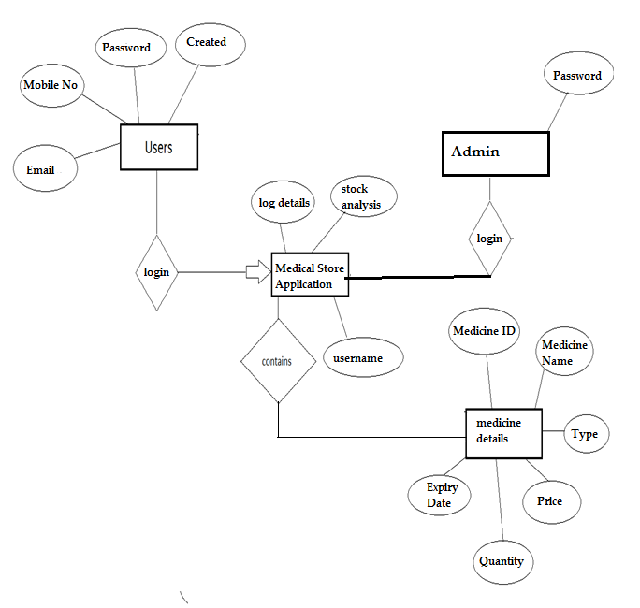

**5. Snapshots**

**Snapshots**

1. **Home Page**

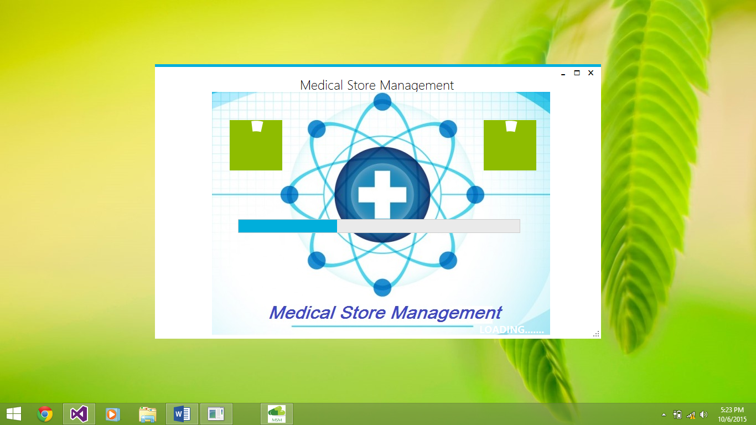

1. **Registration Page**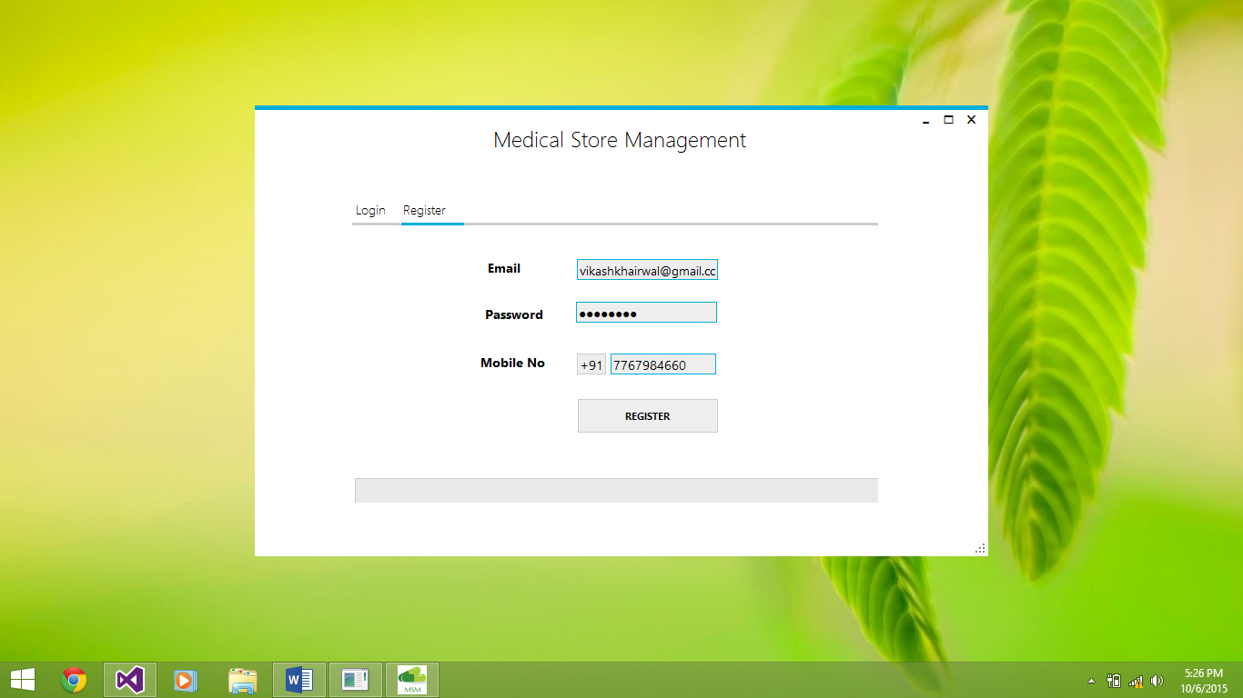
2. **Login Page**

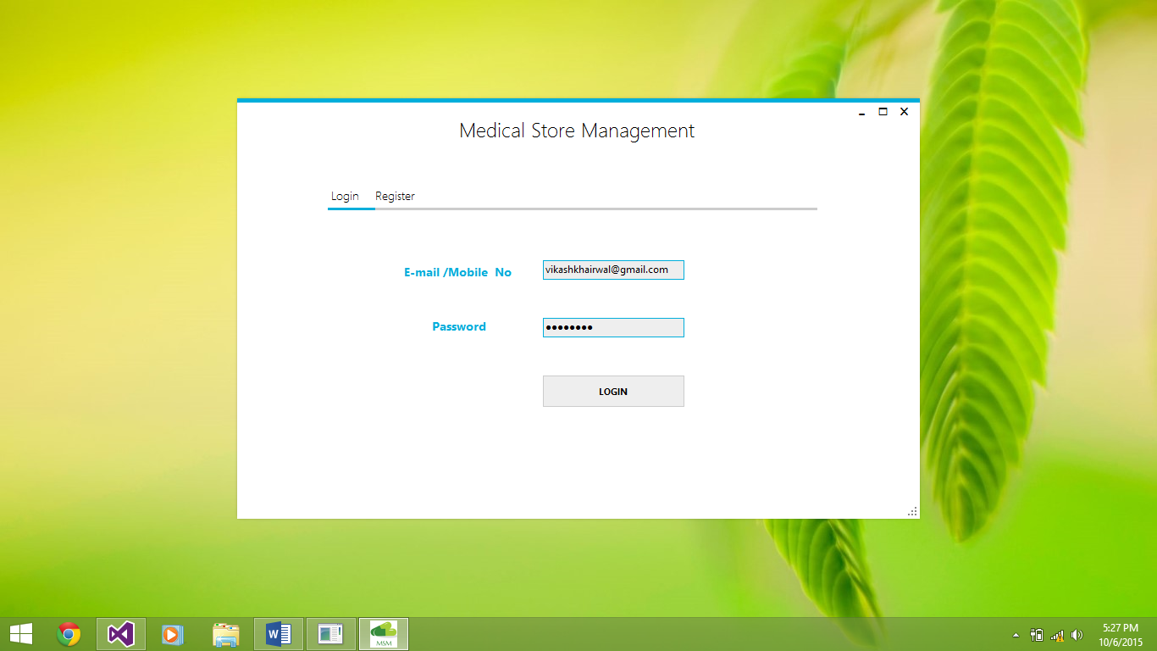

1. **User Access Medical Store App Pages**
2. **Medicine Insertion Page**

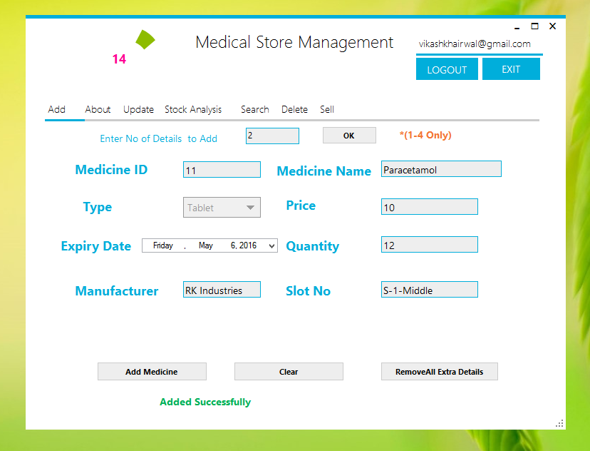

**b) Stock Analysis Page**

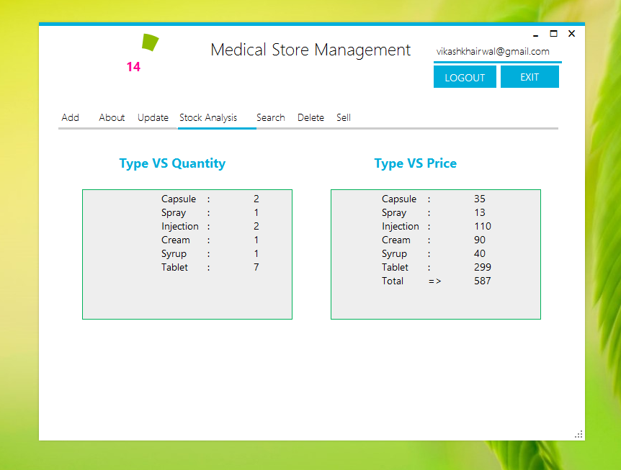

1. **About Application Page**

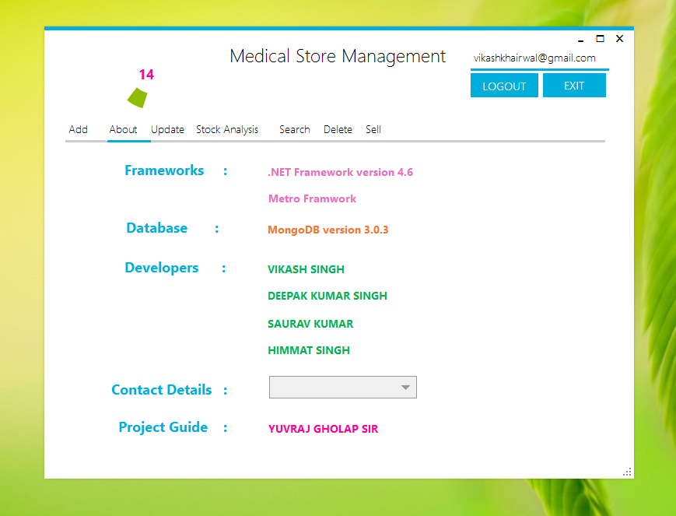

1. **Admin Page**

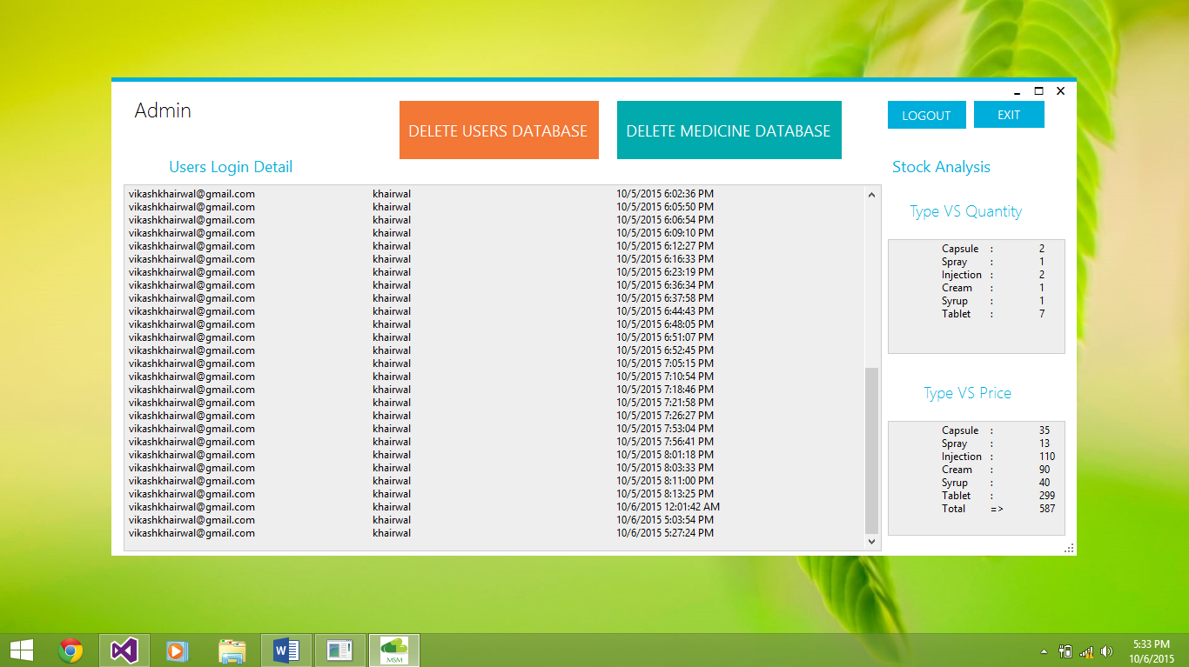

**6. Conclusion**

We have implemented the Medical Store Management successfully. We used C# as programming language on .NET Framework 4.6 and Metro Framework and MongoDB as backend tool as database.

The system is very good at saving the precious time of medical shop owners as well as reduces the work load of medical store staff.

It is a modern method of storing, retrieving the medicine information widely accepted and hastily increasing environment of conducting managing medicines through software in all the sectors of medical stores.

It will considerably replace the traditional paper and pen based information storing in future with Medical Store Management Application.

**References:**

1. <http://www.mongodb.org> : Basics of Mongo DB as well as crude concepts

2. <http://en.wikipedia.org/wiki/MongoDB> : History and theory of mongo DB

3. <http://university.mongodb.com> : For MongoDB for .NET Developers Course

4. <http://denricdenise.info/2014/09/how-to-use-metroframework> : For Basics of Metro Framework